8 BIT ARITHMETIC OPERATIONS

## Exp No:1 Name : Kshitij Sharma

Date: 23/08/2020 Reg No: 185001080

**Aim:-**

To write Programs for 8 bit arithmetic operations : addition , subtraction , Multiplication and Division.

# Procedure:-

* Write the code for 8 bit arithmetic operation and save it as .asm file.
* Mount the folder containing the files in D drive
* Change to D directory.
* Use “edit filename.asm” to Create or Edit the file
* Execute “masm filename.asm” to generate object file.
* Execute “link filename.obj” to generate executable file
* Run “debug filename.exe” to execute file.
* Options during Debug
  + –u :- ( unassemble) : To see the assemble code.
  + –d :- (data segment) . To see the data segment values.
  + –g :- ( execution). To execute the program normally.
  + –e :- (edit). To enter data .
  + –q :- quit. To quit debugging.

# Algorithm:-

1. **8 bit add :**
   * Move the date segment to the AX register. Then move it to the DS register.
   * Move the first operator to AH register.
   * Move the second operator to the BH register.
   * Initialize the CH register with 00H
   * Then add the both register value with add ah,bh.
   * Move the carry bit value to the CH register.
   * If carry value is 1, increase by 1 by using “inc ch”.
   * If carry value is 0, jump to next statement.
   * The result will be stored in ah register.
   * The carry value will be stored in ch register.
   * We int 21h= ah the program will be terminated.

# 8 bit sub:

* + Move the date segment to the AX register. Then move it to the DS register.
  + Move the first operator to AH register.
  + Move the second operator to the BH register.
  + Initialize the CH register with 00H
  + Then subtract both register value with sub ah,bh.
  + If carry value is 1, increase CH by 1 by using “inc ch” and find 2’s comp of AH.
  + If carry value is o, jump to next statement.
  + The result will be stored in ah register.
  + The sign value will be stored in ch register.
  + We int 21h= ah the program will be terminated.

# 8 bit mul:

* + Move the date segment to the AX register. Then move it to the DS register.
  + Move the first operator to AL register.
  + Move the second operator to the BL register.
  + Then mul the both register value with mul bl.
  + The result will be stored in AX register.
  + We int 21h= ah the program will be terminated.

# 8 bit div:

* + Move the data segment to the AX register. Then move it to the DS register.
    - Load 00H in the AH register.
    - Move the first operator to AL register.
    - Move the second operator to the BL register.
    - Then div the both register value with div bl
    - The quotient will be stored in AL register.
    - The remainder will be stored in AH register.
    - We int 21h= ah the program will be terminated.

# Program:-

**1. 8 bit addition:**

|  |  |
| --- | --- |
| **PROGRAM** | **COMMENTS** |
| MOV AX,DATA | Transfer the data to ax register |
| MOV DS,AX | Transfer the the value of ax register to data segment register |
| MOV AH,OPR1 | To transfer the value from opr1 to ah register |
| MOV BH,OPR2 | To transfer the value from opr2 to bh register |
| MOV CH,00H | Initialize 00 value in ch register |
| ADD AH,BH | ah=ah+bh |
| JNC HERE | Jump to Label Here if there is no carry |
| INC CH | Increment value of ch by one i.e, ch=ch+1 |
| HERE: MOV RESULT,AH | The value of ah will be transfer to result |
| MOV CARRY,CH | The value of the carry bit we be seen in carry |
| MOV AH,4CH | Loads 4ch value in ah register |
| INT 21H | Interrupts the Program |

**Snapshot:-**

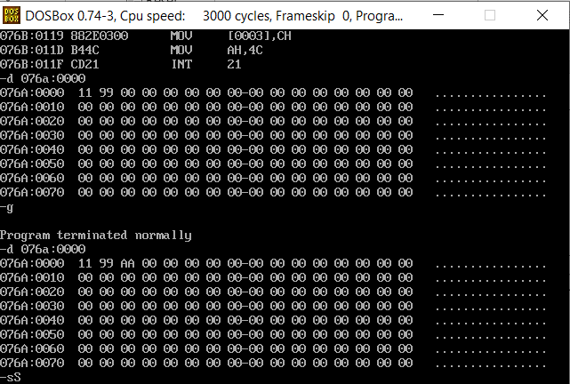

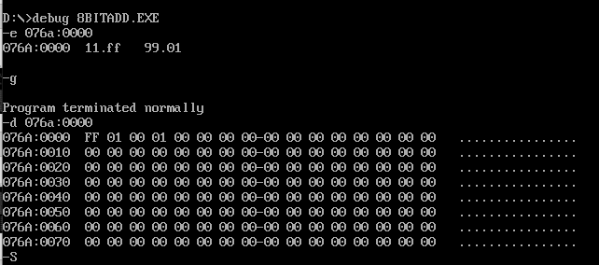

**2 8 bit Subtraction:**

|  |  |
| --- | --- |
| **PROGRAM** | **COMMENTS** |
| MOV AX,DATA | Transfer the data to ax register |
| MOV DS,AX | Transfer the the value of ax register to data segment register |
| MOV AH,OPR1 | To transfer the value from opr1 to ah register |
| MOV BH,OPR2 | To transfer the value from opr2 to bh register |
| MOV CH,00H | Initialize 00 value in ch register |
| SUB AH,BH | ah=ah-bh |
| JNC HERE | Jump to Label Here if there is no carry |
| NEG AH | Stores the 2’s compliment of ah in ah |
| INC CH | Increment value of ch by one i.e, ch=ch+1 |
| HERE: MOV RESULT,AH | The value of ah will be transfer to result |
| MOV CARRY,CH | The value of the carry bit we be seen in carry |
| MOV AH,4CH | Loads 4ch value in ah register |
| INT 21H | Interrupts the Program |

**Snapshot:-**

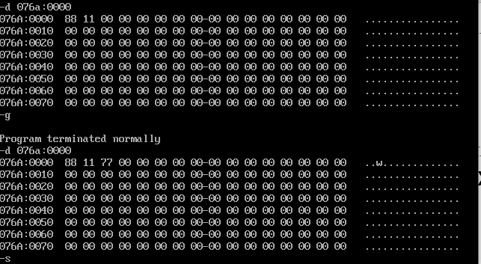

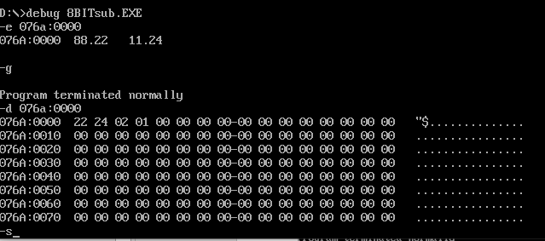

1. **8 bit Multipaction:**

|  |  |
| --- | --- |
| **PROGRAM** | **COMMENTS** |
| MOV AX,DATA | Transfer the data to ax register |
| MOV DS,AX | Transfer the the value of ax register to data segment register |
| MOV AL,OPR1 | To transfer the value from opr1 to al register |
| MOV BL,OPR2 | To transfer the value from opr2 to bl register |
| MUL BL | ax = ax * bl |
| MOV RESULT,AX | The value of ax will be transfer to result |
| MOV AH,4CH | Loads 4ch value in ah register |
| INT 21H | Interrupts the Program |

**Snapshot:-**

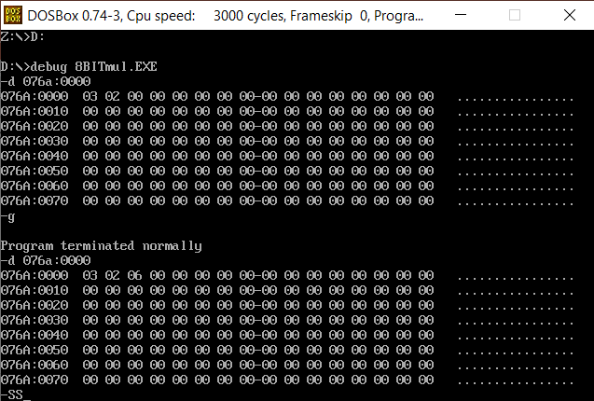

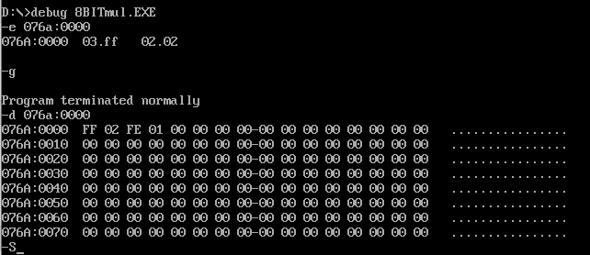

1. **8 bit Division:**

|  |  |
| --- | --- |
| **PROGRAM** | **COMMENTS** |
| MOV AX,DATA | Transfer the data to ax register |
| MOV DS,AX | Transfer the the value of ax register to data segment register |
| MOV AH,00H | Loads value 00 in ah register. |
| MOV AL,OPR1 | To transfer the value from opr1 to al register |
| MOV BL,OPR2 | To transfer the value from opr2 to bl register |
| DIV BL | al=al/bl & ah = al%bl |
| MOV RESULT,AL | The value of al will be transferred to result |
| MOV REM,AH | The value of ah will be transferred to Rem |
| MOV AH,4CH | Loads 4ch value in ah register |
| INT 21H | Interrupts the Program |

**Snapshot:-**

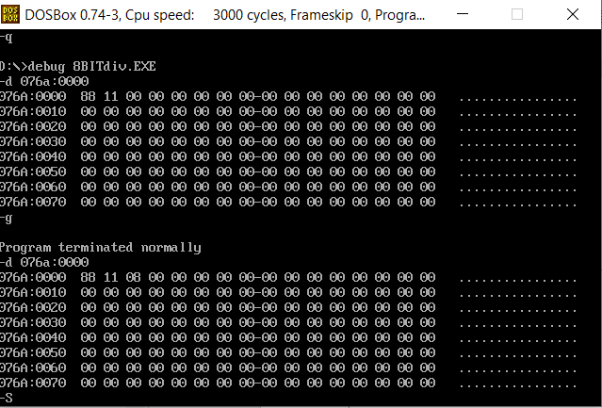

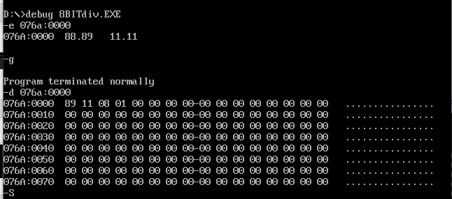

**Result:-**

## Thus the above program executed successfully in the assembler by the dosbox environment.